Executive Liability Insurance
de-SPAC Discussion

Prepared for:

ABC Company

Presented by:

Aaron Lavespere
EPIC Insurance Brokers & Consultants

Rachelle Best
RT ProExec

June 2022

Table of Contents:
- Introduction
- D&O Program Structure Review
- D&O Industry Update
- D&O related SPAC concerns and SPAC Litigation
- Key de-SPAC Coverage Issues
- Placement Strategy
- Limits Modeling Data
- Marketplace Update
Appendix A. Securities Litigation Loss Prevention
Appendix B. Notable D&O Related Supreme Court Decisions
Appendix C. Claims Management & Additional Resources

I. Introduction

The public company Directors and Officers Liability insurance market had been experiencing a softening underwriting environment until 2018. Insurers had been allowing slight decreases on primary and lower excess layers, while competing intensely on higher excess placements. Beginning in the second half of 2018 and then intensifying in 2019 and 2020, the D&O marketplace firmed dramatically from a premium perspective - especially for higher risk classes of business. Lower excess placements have witnessed even larger increases in comparison to past placements. Insurers continue to pay close attention to retentions and are imposing increases when retentions are below their target levels. As discussed in greater detail below, this is a result not only of increased losses in the D&O space, but also negative developments in the overall insurance industry over the past several years. In particular, the D&O carriers viewed the Cyan decision as a major increase in D&O litigation risk for companies with initial public or follow on offering exposure. As a result, the D&O market for companies conducting IPOs has become the hardest that it has been since the early 1990s. Premiums have increased significantly and retentions are much higher than they have ever been. As discussed in greater detail in the following pages, the 2020 Delaware Supreme Court decision in the Salzberg v. Sciabacchuchi case has provided meaningful relief from state court IPO and follow on offering claims. While coverage remains very broad, some underwriters are attempting to narrow their policies in certain areas.
Additional capacity continues to enter the D&O marketplace. The majority of the capacity is still focused on the higher excess layers, but some markets have begun to provide credible primary quotes as well - although there is merger and acquisition activity afoot as well which is consolidating some of the insurers. In any case, the abundance of capacity is certainly a positive from the insured’s perspective. The key is convincing the insurers to deploy their capacity in an effective manner. The COVID 19 pandemic has also impacted the D&O insurance marketplace on several levels.
We have prepared this document to help you navigate the D&O purchasing process as a publicly-traded company. We appreciate the opportunity to represent you with regard to your D&O insurance purchasing needs and look forward to representing your interests in this evolving marketplace.
II. D&O Program Structure Overview

The traditional D&O policy consists of what are generally referred to as Insuring Agreements “A,” “B” and “C” that afford coverage as illustrated below. Whereas coverage for shareholder class actions (generally defined as Securities Claims) under Insuring Agreements B and C has traditionally been the main focus of underwriters and Insureds, the dynamics of today’s risk environment have significant coverage implications for “A-Side” claims as well. Typically, Securities Claims are brought against both the corporate entity and the individual directors and officers, thus triggering both Insuring Agreements B and C of the D&O policy. It may be helpful to think of sides B and C as “balance sheet protection,” whereby the insurance pays on behalf of the corporate entity for its costs to defend itself and its individual directors and officers.
Insuring Agreement A provides “worst case scenario” protection for the personal assets of the directors and officers, responding when the corporate entity does not have the financial ability to indemnify them, as well as in situations where it is deemed to be against public policy for the corporation to indemnify its directors and officers. Of particular note, the A-Side of the policy is often called upon to pay settlements and judgments in shareholder derivative suits, where the claim is being brought by shareholders on behalf of the company.
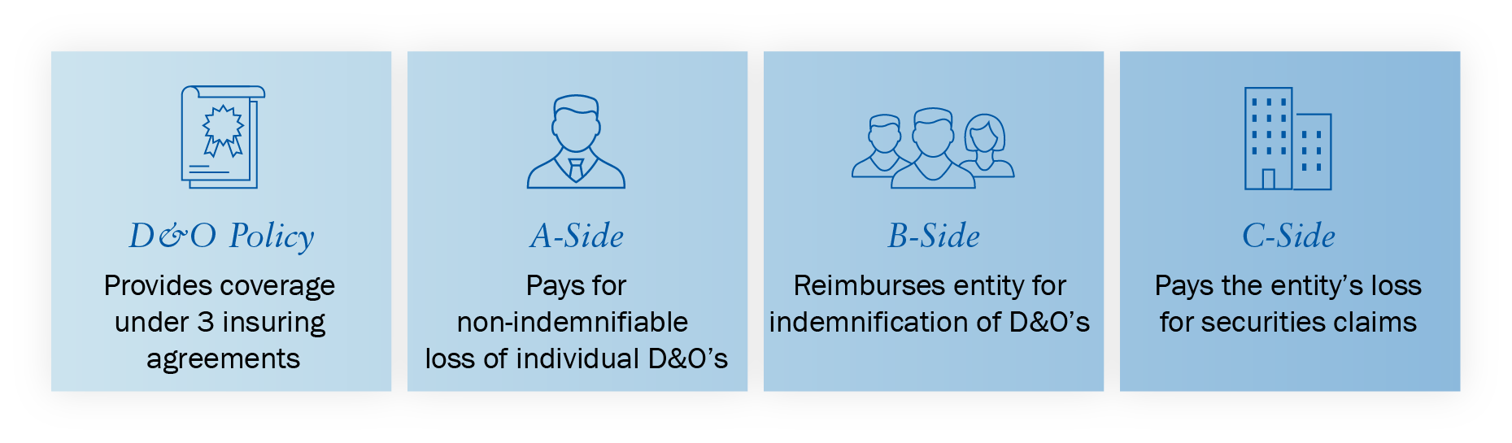
Due to the increase in regulatory enforcement activity, modern D&O policies can be amended to include coverage for “pre-claim” inquiry costs incurred by directors and officers to prepare for and respond to requests by an Enforcement Body that an insured person appear at a meeting or interview, or produce information relating to the Company’s business.

The Risks Inherent in Traditional D&O Policy Structure
While it is generally advantageous to have a D&O policy that provides balance sheet protection, there are situations where having Insuring Agreements A, B and C under one policy may be problematic.
Bankruptcy Since the Corporate Entity is covered under the traditional policy, the policy may be subject to an automatic stay provision imposed in bankruptcy that prevents the insured persons from receiving disbursements for their defense costs.
Limit Loss In a limit loss situation, the directors and officers may find themselves without adequate coverage as a result of the inclusion of coverage for the corporate entity and all employees in the traditional policy.
Restrictive Primary Terms The individual directors and officers could find themselves without coverage for issues that would be covered by a traditional D&O policy were it not for a specific exclusion (e.g., pollution or ERISA claims) in situations where the company cannot indemnify them.
THE D&O POLICY IN BANKRUPTCY Given the publicity surrounding high-profile “corporate meltdowns,” the subject of the D&O policy in bankruptcy has received much attention. Due to the presence of entity coverage for securities claims under Insuring Agreement C, some courts have deemed the D&O Policy an asset of the bankruptcy estate while others have not.

For the individual directors and officers, the ramifications of the court’s decision in this regard are enormous. If the policy is considered an asset of the bankrupt estate, the court may “freeze” the proceeds of the policy. The stay will likely prohibit payment of defense costs and this can expose the directors and officers to significant personal liability, for while claims against the company are stayed during the pendency of the bankruptcy, the directors and officers are not similarly protected.
Staggered Settlements If the corporate entity, or a group of defendant directors or officers settles, they erode - and could exhaust - the limits available for the non-settling defendants.

The Benefits of A-Side “Difference in Conditions” (DIC) Policies
Augmenting the traditional A-B-C program with a separate A-Side “Difference in Conditions” (DIC) Policy is beneficial for a number of reasons:
- Only the individual directors and officers are covered, therefore, the bankruptcy court cannot argue that the policy is the property of the debtor entity
- An A-Side policy will state that it cannot be rescinded under any circumstances
- An A-Side policy should be very broad, contain very few exclusions (i.e., no ERISA, bodily injury or pollution exclusions, and a limited or deleted Insured versus Insured exclusion) and will drop down in key situations when other coverage is unavailable
- Since the A-Side form covers only the individual directors and officers for their non-indemnifiable loss, the policy is not diluted by payments on behalf of other insureds
- The coverage provided by the latest generation A-Side forms is more favorable to directors and officers than ever before
Thus, with the ever-changing challenges of the economic environment and the increased frequency of enormous D&O settlements, companies are enthusiastically adopting dedicated A-Side DIC policies that sit excess of the traditional D&O policy or program.
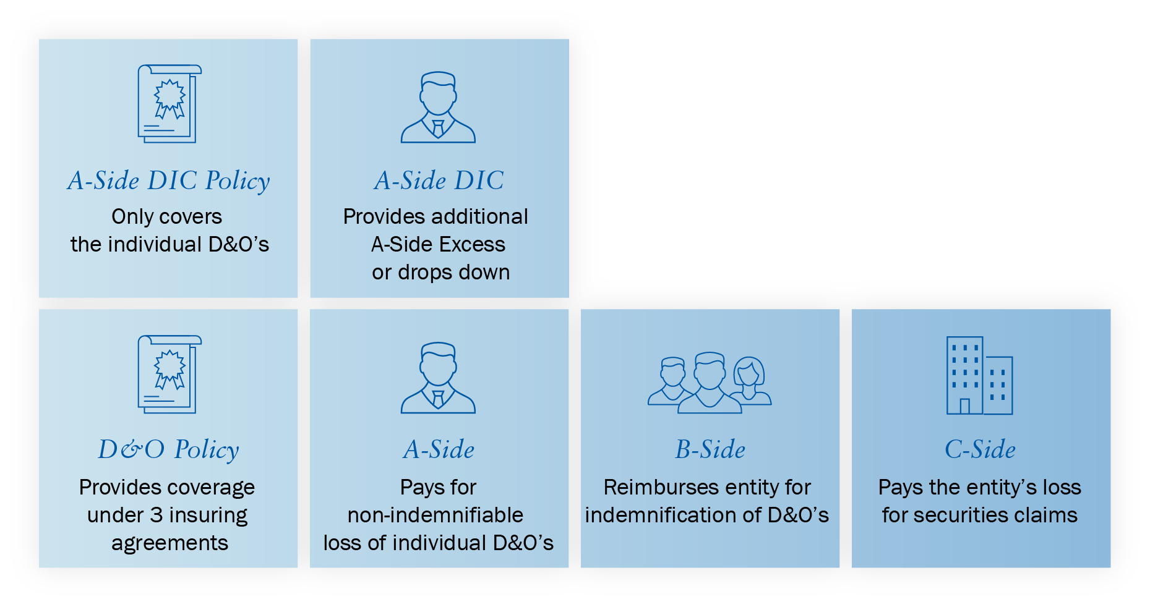

III. Key Issues Summary
The D&O marketplace for publicly traded companies is stabilizing
- As a result of the premium and retention increases that the public company D&O marketplace had demanded for the past three years, insurers’ profitability has begun to improve and the D&O market is beginning to soften.
- Absent any material negative developments in the risk, carriers are seeking much smaller premium increases on primary placements, and in a growing number of instances, are agreeing to decreases.
- At this point, there is no market consensus on the decreases which range from small to quite large – depending on the insured’s risk profile and the expiring premium level.
- Primary carriers also appear to be comfortable with their current limit capacity and coverage terms. We are generally not seeing the insurers further restrict coverage or limit capacity in the current renewal cycle.
- Excess insurers’ premiums are also moderating. Compared to the past several years when excess insurers were pricing their layers at rates equivalent to 85% or more of the layer directly underneath them, excess rates are now dropping into the mid-70s and lower in some instances.
- The marked improvement in excess pricing is mainly attributable to the influx of new excess insurers into the marketplace. Most of the new capacity is still not targeting primary placements, which has resulted in less competitive pressure on primary layers.
- Accounts that have experienced significant growth or stock volatility, claims, or other material increases in risk profile may still see significant increases in premium and/or retentions.
- The increased risk factors from the Cyan decision and the COVID-19 pandemic have receded meaningfully and are not factoring into current renewals.
- The frequency of shareholder class action litigation has also decreased over the past several years, but securities related regulatory activity is on the rise (as discussed further below).

Pre and Post-Cyan Quarterly Federal Section 11 and State 1933 Act Filings 2016 – 2021
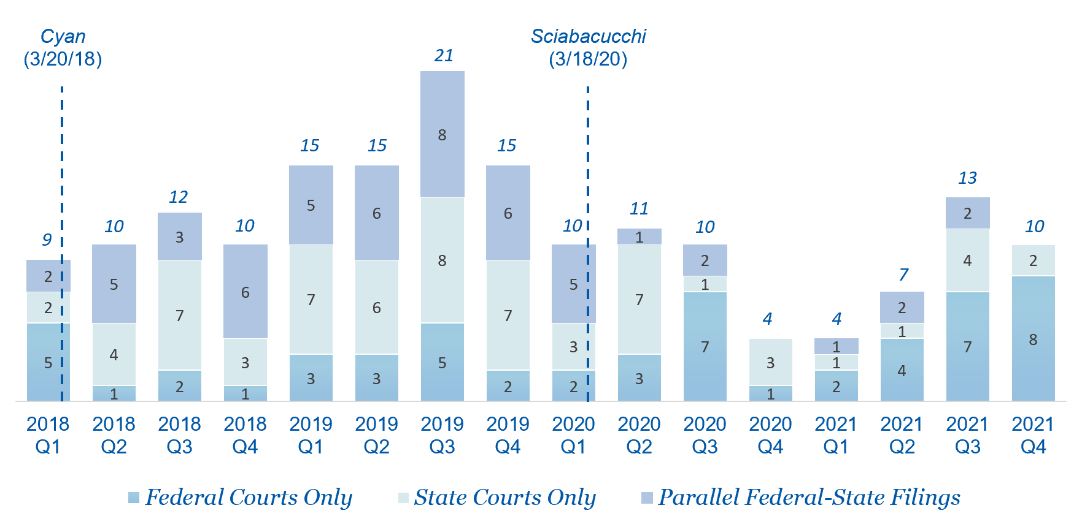
Source: Cornerstone Research and Stanford Law School Securities Class Action Clearinghouse; Bloomberg Law; ISS’ SCAS
A Brief History of State Court Jurisdiction over IPO Suits

D&O Insurers are returning to profitability
- Taken as a whole, at the end of 2021, the top D&O insurers’ underwriting results moved into a profitable position. The average loss and defense ratio for the top US D&O insurers finished 2021 at 66.1%. This, coupled with an average expense ratio of approximately 30%, places the combined ratio at approximately 96%.
- This means that these insurers are making an underwriting profit as of the end 2021.
- This is good news as it should lead to additional competition between insurers and result in premium decreases.
- The pandemic-induced backlog in the courts may be favorably impacting these results, and the loss ratios may once again deteriorate as cases move through the system.

2021 D&O Insurer Rankings and Loss Ratio Performance

Company Name | $ Written Premium (millions) | % premium growth vs 2020 |  | 2021 | 2020 | 2019 | 2018 | 2017 | 2016
AXA XL | 2,284 | 57.2 |  | 57.6 | 67.5 | 71.6 | 75.7 | 61.2 | 59.2
Chubb | 1,357 | 24.8 |  | 48.5 | 88.5 | 67.0 | 57.5 | 65.4 | 54.5
American International Group | 1,208 | 23.1 |  | 62.8 | 73.8 | 86.8 | 96.7 | 112.8 | 93.1
Tokio Marine (HCC) | 971 | 28.8 |  | 70.3 | 66.0 | 59.3 | 58.0 | 54.5 | 57.0
Fairfax Financial | 862 | 67.3 |  | 57.3 | 56.9 | 63.0 | 71.5 | 63.2 | 58.4
Berkshire Hathaway | 606 | 47.6 |  | 70.2 | 82.2 | 84.3 | 69.8 | 69.4 | 62.6
W. R. Berkley | 597 | 70.3 |  | 72.4 | 88.1 | 77.2 | 78.4 | 72.7 | 32.5
Sompo | 552 | 27.2 |  | 73.6 | 70.6 | 71.3 | 51.0 | 70.7 | 56.4
Zurich | 524 | 42.0 |  | 86.2 | 47.2 | 62.4 | 79.9 | 120.2 | 119.8
CNA | 523 | 19.3 |  | 63.5 | 60.7 | 65.1 | 59.0 | 74.5 | 86.6
Arch Insurance | 476 | 87.1 |  | 73.0 | 84.4 | 81.4 | 88.5 | 39.2 | 32.9
Travelers | 471 | 11.5 |  | 77.4 | 86.7 | 44.4 | 36.2 | 52.3 | 44.0
Old Republic | 335 | 35.3 |  | 63.7 | 64.6 | 65.9 | 63.3 | 71.0 | 49.2
Great American | 320 | 12.8 |  | 51.8 | 66.8 | 63.2 | 58.8 | 60.9 | 47.8
Markel Corporation | 320 | 56.7 |  | 62.5 | 47.9 | 63.7 | 109.1 | 138.8 | 52.2
Average – Top 15 | 10,882 | 40.7 |  | 66.1 | 70.1 | 68.4 | 70.2 | 75.1 | 60.4
Source: A.M. Best 2022 Report on D&O Insurer Performance
SCAS Litigation Filings and Frequency decreased in 2021
- From 1997-2020, an average of 228 Shareholder Class Actions were filed each year.
- In 2021, 218 Shareholder Class Action suits were filed. This represents a 34.5% decrease from the 333 cases filed in 2020.
- Of particular note, there were 8 state court only lawsuits in 2021, down from 14 in 2020 and from 28 in 2019. This appears to be directly attributable to the insured-favorable decision in the Sciabacucchi case regarding federal forum provisions and the subsequent case dismissals in the California courts.
- In addition, the number of merger and acquisition objection class actions plummeted in 2021 to 18 cases, down from 99 in 2020 and 160 in 2019. This trend is the result of plaintiffs’ firms shifting their strategy to bringing these cases as individual actions as opposed to class actions.
- In 2021, plaintiffs’ firms brought 210 single-plaintiff federal merger objection lawsuits, down from 450 in 2020. 75% of these actions were voluntarily dismissed shortly after the complaints were filed, in return for additional immaterial disclosures and the payment of confidential mootness fees to plaintiff’s counsel.
- As these federal court mootness fee settlements provide no benefit to the company shareholders and serve as a deal tax on almost every M&A transaction involving a public company, we are hopeful that regulatory scrutiny will soon be brought to bear on this racket.
- Of the 2021 federal court securities lawsuit filings, 200 were “core” lawsuits (i.e. not merger objection related). This is a decline of 14.5% from the 234 core filings in 2020. The 2021 core filings tally is still slightly above the 1997-2020 average of 192 core filings per year.
- The 1997-2020 average annual percentage of public companies with core securities class action claims is 4%. In 2021, 3.8% of major exchange listed companies were sued in a core securities class action lawsuit. This is a drop from the 4.2% rate in 2020 and from the 5.5% rate in 2019. 2020 represented the first drop in frequency in 8 years and 2021 continued the downward trend.

Federal Shareholder Class Action Litigation Trends
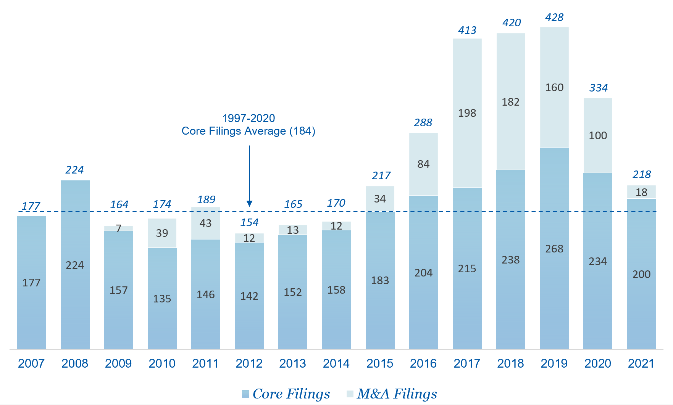
Source: Cornerstone Research

Federal Shareholder Class Action Litigation Frequency
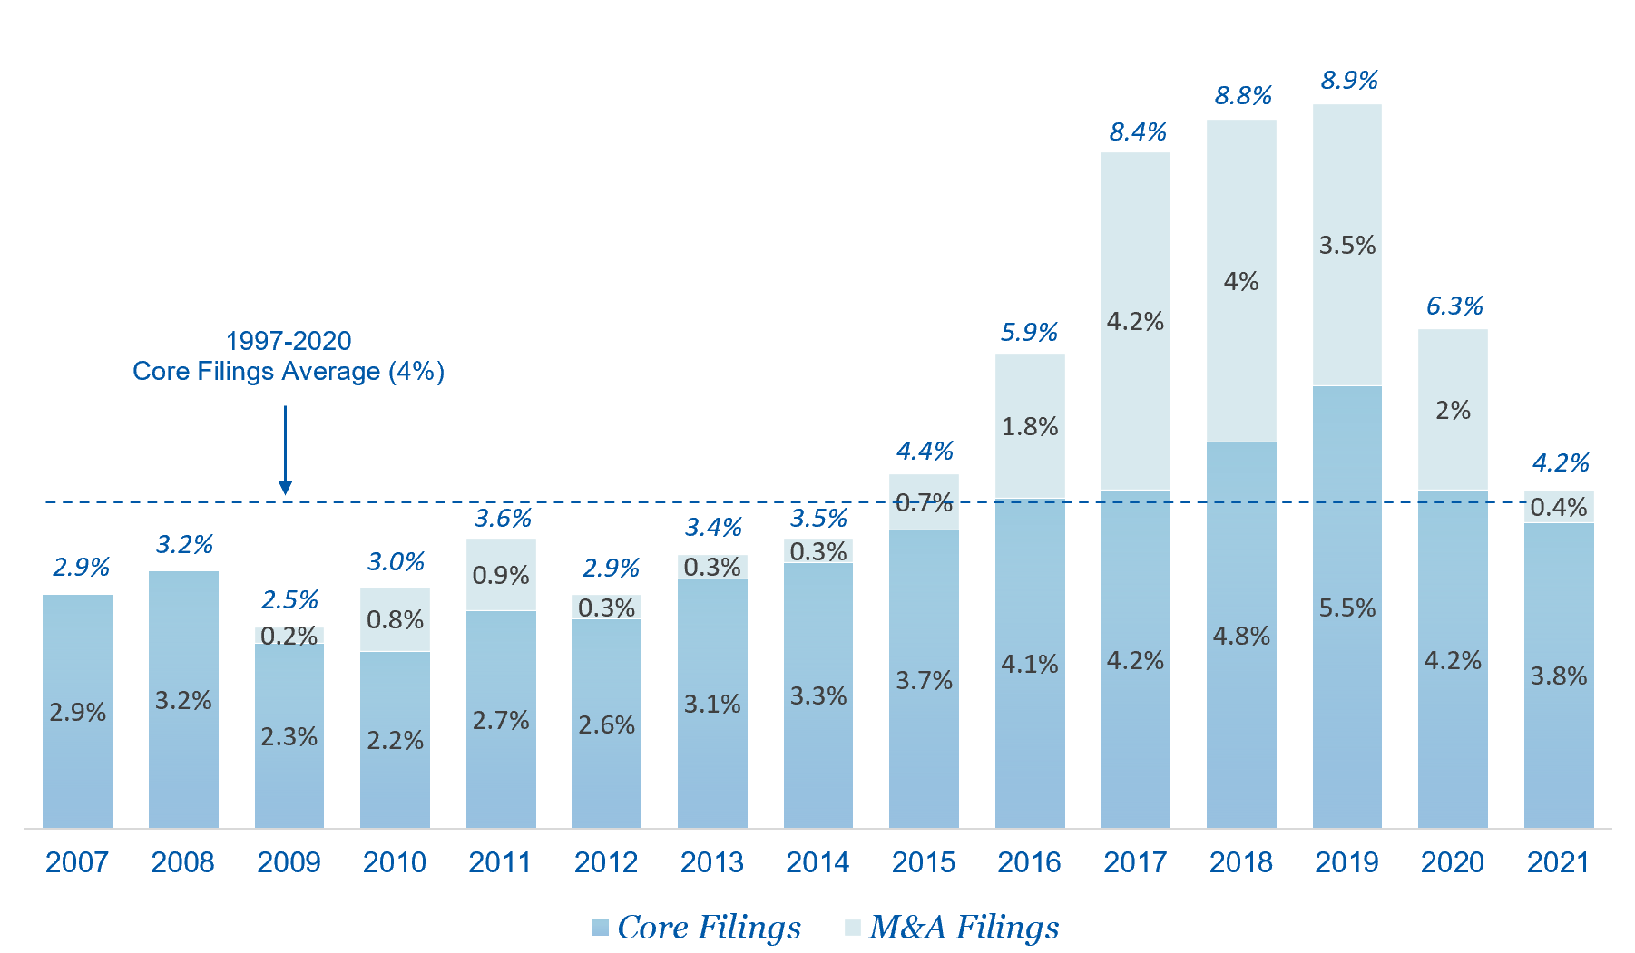
Source: Cornerstone Research
Federal Shareholder Class Action Fillings and Number of Exchange Listed Companies
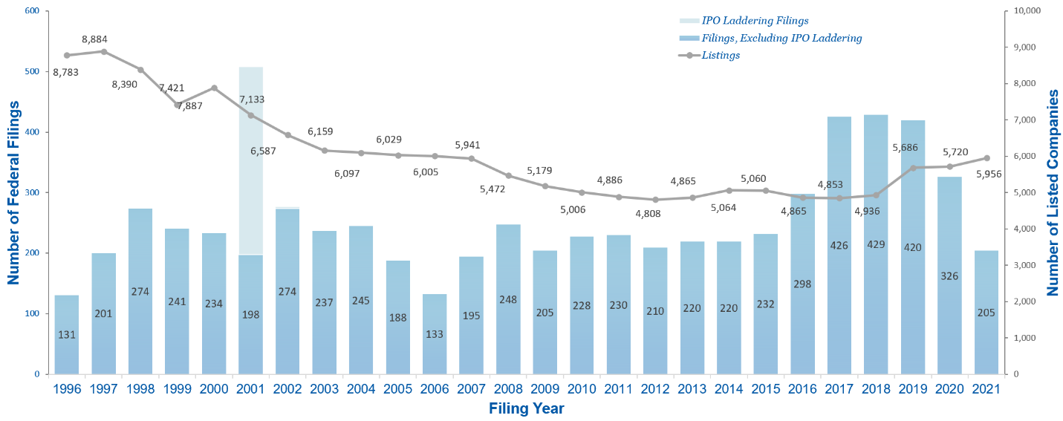
Source: Nera Economic Consulting
Note: Listed Companies include those listed on the NYSE and Nasdaq.
Listings data obtained from World Federation of Exchanges (WFE)

Government Regulatory Activity will very likely increase under the Biden Administration
- Based on the Biden administrations comments so far, it appears that they have an enforcement philosophy that is similar to that of the Obama administration, which was not friendly to public companies and their directors and officers.
- An early indicator of this trend can be found in the record shattering Fiscal Year 2021 (which ended on September 30) results for the SEC Whistleblower program, both in terms of the number of awards and the dollars awarded.
- The SEC awarded a record $564 million to 109 individuals in FY 2021. This is over three times the $175 million in total whistleblower awards to 39 individuals in FY 2020 which, in turn was nearly three times the $60 million awarded to 8 whistleblowers in FY 2019.
- In fact, the $564 million awarded in FY 2021 is more than the $562 million for all the awards from the inception of the program in 2011 through the end of FY 2020. To put it another way, the SEC awarded more money in FY 2021 than in all other years of the program combined.
- In October of 2020, the SEC announced that it had awarded a record setting $114 million award to an individual whistleblower, eclipsing the previous record of $50 million. In September of 2021, the SEC awarded another $114 million to two individuals.
- The agency received 12,210 whistleblower reports in FY 2021, representing a 76% increase over FY 2020, when the agency received 6,911 reports.
- The SEC brought 697 enforcement actions in FY 2021, a 2.5% decline from the 715 enforcement actions in FY 2020. The FY 2021 tally is materially lower than the 862 enforcement actions in FY 2019 and 821 in FY 2018. In FY 2017, enforcement actions had fallen to 754 (from 868 in FY 2016).
- In FY 2021, the number of independent enforcement actions rose to 434, an increase of 7% over the 405 in FY 2020. Although still below the 526 brought in FY 2019. By way of context, there were 490 in FY 2018, 446 in FY 2017, 548 in FY 2016, 507 in FY 2015 and 413 in FY 2014.
- We do not believe that the recent lower frequency of SEC enforcement actions portends a material decrease in the risk of SEC enforcement activity, but rather is the result of pandemic related shutdowns. As discussed above, we feel that the risk of regulatory action will increase significantly as we move forward.

Board Diversity Lawsuits are not faring well in the courts
- Most of the shareholder lawsuits filed in 2020 and early 2021 which accused boards of violating their legal duties by failing to diversify the company’s board and otherwise failing to address diversity and equality issues have been dismissed.
- The SEC approved the NASDAQ “Comply or Explain” governance diversity rules in August of 2021, which require NASDAQ listed companies to have, or to explain why they do not have, at least two members of its board of directors who are “Diverse,” including at least one Diverse director who self-identifies as female and at least one Diverse director who self-identifies as an underrepresented minority or LGBTQ.
- In April and May of 2022, California superior court judges struck down California’s board diversity statute and the California statute that requires California based public companies to have from 1 to 3 female directors as violations of the California constitution’s equal protection clause
A wave of new D&O insurers is breaking onto the marketplace
- As is true of all financial systems, the D&O marketplace is primarily governed by the laws of supply and demand. When supply is tight, prices rise and as the supply of insurance capacity grows, prices inevitably fall.
- The firming of the D&O market has attracted a raft of new capacity. We are seeing this new capacity have a positive impact on the excess layers and expect that the new carriers will begin to be helpful on primary placements as we move through 2022.
- The list of new carriers that have entered the market or are entering soon includes capacity domiciled in the U.S., as well as Bermuda and London, including:

 |  | 
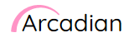 |  | 
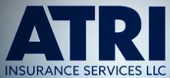 |  | 
 |  | 
 |  | 
D&O Coverage quality remains intact
- It appears that the premium and retention adjustment discussed above have been effective at improving D&O insurers’ profits.
- We had begun to fear significant coverage pull backs given the drastic hardening of the market that occurred in 2019 and 2020.
- However, at this point, it appears that the level of coverage in the D&O marketplace for public companies remains stable. We will continue to monitor this carefully and work to broaden coverage as we move forward.

IV. SPAC Related D&O Concerns and SPAC Litigation
The increased prevalence of SPAC offerings and transactions and the Nikola headlines have increased the perceived D&O risks surrounding SPACs.
- In 2021 there were 613 new SPAC offerings that raised almost $162 billion in proceeds, on top of the 248 SPACs that raised nearly $83 billion in 2020, which was dubbed the "year of the SPAC”. This compares to 59 offerings in 2019, which raised over $13 billion, itself a record high.
- With the backdrop of the hardest D&O market in decades for most other publicly traded companies and IPOs, D&O underwriters had already begun to grow wary of the spike in SPAC offerings and had started to slowly raise prices and pull back on capacity.
- The September 10, 2020 report by the short seller firm Hindenburg Research on Nikola (which became public through a June 2020 de-SPAC merger with VectoIQ) led to a series of shareholder class action claims against Nikola as well as an SEC investigation which culminated in a recent grand jury indictment of Trevor Milton, the former CEO of Nikola.
- On April 8, 2021, John Coates, the Acting Director of the SEC Division of Corporate Finance, issued a sharp public statement on the legal liability exposures associated with SPACs, warning that “Any claim about reduced liability exposure for SPAC participants is overstated at best, and potentially seriously misleading at worst. Indeed, in some ways, liability risks for those involved are higher, not lower, than in conventional IPOs, due in particular to the potential conflicts of interest in the SPAC structure.”
- Less than a week later, on April 12, 2021, the SEC sent out a public statement warning that SPAC warrants may need to be classified as liabilities depending on their payout structure, settlement in cash or stock, or whether their value is indexed solely to the performance of the underlying stock.
- Also on April 12, the Robbins Geller plaintiffs’ law firm issued a press release stating that they were forming a task force “dedicated to rooting out and prosecuting fraud on behalf of injured blank check company investors.”
- According to a July 13, 2021 press release from the SEC, the commission recently settled an administrative proceeding against the space focused de-SPAC Momentus, in return for a cease and desist order and the payment of a $7 million penalty from the company and $1 million from its SPAC merger partner.
- In addition to the regulatory uncertainty and the sheer volume of SPAC offerings D&O insurers are growing increasingly concerned that the number of SPACs looking for deals (587 as of June 30, 2022) and the time pressures to complete a deal may contribute to inadequate due diligence and overlooked risk factors and lead to bad deal litigation.
- On March 31, 2022, the SEC approved a set of proposed rules relating to SPACs and de-SPAC transactions. These rules are currently subject to the public comment period and may change based on the comments received by the SEC. The proposed rules largely focus on the following:
  - Enhancing disclosure and investor protection
  - Revising registration requirements for de-SPAC transactions
  - Projections disclosures
  - SPAC status under the Investment Company Act of 1940
The risk of D&O claims against SPACs comes in several forms including:
- Claims against the SPAC directors alleging breaches of fiduciary duties in failing to consummate a business combination or in taking fees in connection with a dissolution of the SPAC.
- Claims brought by a target company or its shareholders arising from a broken deal alleging wrongful acts in connection with the SPAC’s conduct in performing due diligence on, or otherwise interacting with, the target company.
- Claims against the SPAC directors alleging breaches of fiduciary duty arising from alleged conflicts of interest, failure to conduct a fair process, failure to secure an adequate value for the SPAC or inadequate due diligence in connection with a business combination.
- Claims against the SPAC and its directors and officers arising from alleged misrepresentations in the proxy statement filed in connection with a business combination.
- Depending on the allegations, these claims may be brought during the liquidation window, at the time of the announcement of the business combination based on the concerns about the structure of the transaction or the conduct of the combination process or post transaction based on post transaction statements, operations or activities of the combined company.
- Regulatory investigations and proceedings by the SEC (and possibly other regulators) based on any of the above issues.
- In late December 2020, the SEC released its initial guidance for SPAC’s. This information can be found here: https://www.sec.gov/corpfin/disclosure-special-purpose-acquisition-companies
- In 2021, there were 31 SPAC-related securities class action lawsuits (versus 6 for the entire year filed in each of 2020 and 2019)
- Also, there were 14 SPAC-related shareholder derivative lawsuits filed in 2021, as well as at least three Delaware state court direct damages actions alleging breach of fiduciary duty.
- More striking is that SPAC litigation was less than 2% of the total of shareholder litigation filed in 2019 and 2020. In 2021, SPAC litigation comprised 14.7% of the total.
- Of the 31 federal shareholder class actions brought against SPACs in 2021, 20 cases named former directors and officers of the SPAC entity.
- As of June 30, 2022, there have been 17 federal SPAC related shareholder class action suits filed so far in 2022 which represents 17% of all 2022 federal shareholder class action complaints.

Sample SPAC Litigation
Provided below are brief descriptions of several securities class action lawsuits that have been filed in recent months and that involve SPACs. In addition to these class action lawsuits, a number of SPACs recently have been involved in pre-deSPAC litigation in which SPAC shareholders file claims under Section 14(a) of the Securities Exchange Act of 1934, alleging that the pre-merger proxy materials contain misrepresentations or omissions. In the current litigation environment, these merger objection lawsuits typically are filed as individual actions rather than as class action lawsuits. Descriptions of several recent securities class action lawsuits follow.

SPAC Name | Social Capital Hedosophia Holdings Corp.
Target Name | Virgin Galactic
SPAC IPO Date | September 15, 2017
de-SPAC Date | October 25, 2019
Case Filing Date | May 28, 2021
SPAC Defendants | No

Virgin Galactic is an aerospace company seeking to develop consumer space travel. The securities class action complaint was filed shortly after the company restated its financials in order to change its accounting treatment of warrants on its balance sheet (pursuant to the SEC’s April 2021 guidance on warrant accounting issues).
The complaint purports to be filed on behalf of a class of investors who purchased Virgin Galactic securities between October 26, 2019 (the day the merged company’s securities began trading on the public markets) and April 30, 2021 (the day Virgin Galactic announced its reporting delay and restatement). The complaint asserts that during the class period, the defendants made false or misleading statements or failed to disclose that: “(i) for accounting purposes, SCH’s warrants were required to be treated as liabilities rather than equities; (ii) Virgin Galactic had deficient disclosure controls and procedures and internal control over financial reporting; (iii) as a result, the Company improperly accounting for SCH warrants that were outstanding at the time of the Business Combination; and (iv) as a result, the Company’s public statements were materially false and misleading at all relevant times.”
The complaint alleges that the defendants’ statements or omissions violated Sections 10(b) and 20(a) of the Securities Exchange Act of 1934 and Rule 10b-5 thereunder. The complaint seeks to recover damages on behalf of the plaintiff class.
For further information, please click here:
https://www.dandodiary.com/2021/05/articles/securities-litigation/virgin-galactic-hit-with-securities-suit-over-spac-warrant-accounting-issue/

SPAC Name | Churchill Capital Acquisition Corp. IV
Target Name | Lucid Motors
SPAC IPO Date | July 30, 2020
de-SPAC Date | N/A
Case Filing Date | April 18, 2021
SPAC Defendants | Yes

Lucid Motors is an electric automobile development and manufacturing company. On February 22, 2021, Lucid and Churchill Capital Acquisition Corp. IV announced their plan to merge, with Lucid to be the surviving public company. In the days before the merger was announced, the founder and CEO of Lucid had made several public statements about the companies planned vehicle production schedule and plans and rumors of Churchill IV’s possible acquisition of Lucid circulated in the financial press. The share price of Churchill IV soared. After the merger was announced, Lucid’s CEO made public statements with more modest projections of the planned production schedule, causing the share price of Churchill IV to slump.
On April 18, 2021 (that is, before the planned merger had been completed), Churchill IV investors filed a securities class action lawsuit against both the SPAC and Lucid, as well as against certain individual directors and officers of both companies.
The complaint purports to be filed on behalf of a class of investors who purchased Churchill IV securities between January 11, 2021 (the date of the Lucid CEO’s initial optimistic statements about Lucid’s planned production) and February 22, 2021 (the date the merger was announced). The complaint alleges that the defendants violated Sections 10(b) and 20(a) of the Securities Exchange Act of 1934 and Rule 10b-5 thereunder. The complaint seeks to recover damages on behalf of the plaintiff class.
For further information, please click here:
https://www.dandodiary.com/2021/04/articles/securities-litigation/spac-and-target-company-hit-with-pre-merger-10b-5-class-action-suit/


SPAC Name | Centricus Acquisition Corp.
Target Name | Arquit Limited
SPAC IPO Date | February 28, 2021
de-SPAC Date | September 3, 2021
Case Filing Date | May 6, 2022
SPAC Defendants | Yes

Arquit is a London-based cybersecurity company that seeks to develop and market a unique encryption technology. The securities class action lawsuit was filed against Arquit after the Wall Street Journal published a critical article about the company, questioning the company’s capabilities, technology and revenues. The complaint purports to be filed on behalf of a class of investors who purchased the company’s shares between September 7, 2021 (the date the merged company’s shares began trading) and April 18, 2022 (the date the Journal published the article). The complaint alleges, among other things, that in the proxy statement and in SEC’s filings, the defendants failed to disclose that: “(1) Arquit’s proposed encryption technology would require widespread adoption of new protocols and standard of for [sic] telecommunications; (2) British cybersecurity officials questioned the viability of Arquit’s proposed encryption technology in a meeting in 2020; … (4) Arquit had little more than an early-stage prototype of its encryption system at the time of the Merger.”
The complaint alleges that the defendants violated Sections 10(b), 14(a), and 20(a) of the Securities Exchange Act of 1934 and Rule 10b-5 thereunder. The complaint seeks to recover damages on behalf of the plaintiff class.
For further information, please click here:
https://www.dandodiary.com/2022/05/articles/securities-litigation/u-k-based-cybersecurity-firm-hit-with-spac-related-securities-suit/


SPAC Name | Health Sciences Acquisition Corp.
Target Name | Immunovant Sciences, Ltd.
SPAC IPO Date | May 17, 2019
de-SPAC Date | December 19, 2020
Case Filing Date | February 19, 2021
SPAC Defendants | Yes, SPAC CEO

Immunovant is developing a human antibody therapy known as IMVT-1401. The treatment is in Phase II clinical trials. On February 2, 2021, Immunovant issued a press release in which it announced “a voluntary pause of dosing in the ongoing clinical trials for IMVT-1401.”
The complaint purports to be filed on behalf of a class of persons who purchased securities of Immunovant or pre-merger Health Sciences between October 2, 2019 (the date the merger was announced) and February 1, 2021. In her complaint, the plaintiff alleges that the during the class period defendants made false and/or misleading statements and/or failed to disclose that: “(i) HSAC had performed inadequate due diligence into Legacy Immunovant prior to the Merger, and/or ignored or failed to disclose safety issues associated with IMVT-1401; (ii) IMVT-1401 was less safe than the Company had led investors to believe, particularly with respect to treating [certain diseases under investigation]; (iii) the foregoing diminished IMVT-1401’s prospects for regulatory approval, commercial viability, and profitability; and (iv) as a result, the Company’s public statements were materially false and misleading at all relevant times.”
For further information, please click here:
https://www.dandodiary.com/2021/02/articles/securities-litigation/post-spac-acquired-biopharma-firm-hit-with-securities-suit/


SPAC Name | Social Capital Hedosophia Holdings Corp. III
Target Name | Clover Health Investments, Corp.
SPAC IPO Date | October 9, 2020
de-SPAC Date | January 7, 2021
Case Filing Date | February 5, 2021
SPAC Defendants | Yes, SPAC CEO

According to the Complaint, Clover Health Investments, Corp. purports to be a Medicare Advantage insurer that uses its software platform, the Clover Assistant, to provide America’s seniors with PPO and HMO insurance plans. On January 7, 2021, Clover merged with SPAC Social Capital Hedosophia Holdings Corp. III and began to trade under the symbol CLOV on NASDAQ. On February 4, 2021, Hindenburg Research issued a report stating that prior to the merger, Clover had been under active investigation by the U.S. Department of Justice for issues ranging from kickbacks to marketing practices to undisclosed third-party deals.
The Complaint alleges that during the Class Period, Defendants misled investors by misrepresenting and/or failing to disclose that: (i) Clover was the recipient of a Civil Investigative Demand from the DOJ; (ii) much of Clover’s sales are driven by a major related party deal that Clover not only failed to disclose but took active steps to conceal; (iii) Clover’s subsidiary Seek Insurance failed to disclose its relationship with Clover and misled consumers as to its purported independence; (iv) Clover’s software was in fact rudimentary; and (v) as a result, the Company’s public statements were materially false and misleading at all relevant times.
For further information, please click here:
https://www.dandodiary.com/2021/02/articles/securities-litigation/securities-suit-alleges-failure-to-disclose-doj-investigation-before-de-spac-transaction/


SPAC Name | VectoIQ Acquisition Corp.
Target Name | Nikola Corporation
SPAC IPO Date | May 18, 2018
de-SPAC Date | June 3, 2020
Case Filing Date | September 15, 2020
SPAC Defendants | Yes, SPAC CEO and CFO

According to the Complaint, Nikola Corporation purports to operate as an integrated zero emissions transportation systems provider which designs and manufactures battery-electric and hydrogen-electric vehicles, electric vehicle drivetrains, vehicle components, energy storage systems, and hydrogen fueling station infrastructure.
The Complaint alleges that Defendants throughout the Class Period made false and/or misleading statements and/or failed to disclose that: (1) VectoIQ did not engage in proper due diligence regarding its merger with Nikola; (2) Nikola overstated its “in-house” design, manufacturing, and testing capabilities; (3) Nikola overstated its hydrogen production capabilities; (4) as a result, Nikola overstated its ability to lower the cost of hydrogen fuel; (5) Nikola's founder and Executive Chairman tweeted a misleading “test” video of the Company’s Nikola Two truck; (6) the work experience and background of key Nikola employees had been overstated and obfuscated; (7) Nikola did not have five Tre trucks completed; and (8) as a result, Defendants’ public statements were materially false and/or misleading at all relevant times.
On December 15, 2020, the Court issued an Order consolidating cases and appointing Lead Plaintiff and Counsel.
For further information, please click here:
https://www.dandodiary.com/2020/10/articles/director-and-officer-liability/rain-on-the-spac-parade/


SPAC Name | Modern Media Acquisition Corp.
Target Name | Akazoo, S.A.
SPAC IPO Date | May 17, 2017
Date of de-SPAC | September 11, 2019
Case Filing Date | April 24, 2020
SPAC Defendants | No
According to the complaint, Akazoo, S.A. purported to be a global music streaming service with subscribers in 25 countries on several continents.
The Complaint alleges Defendants throughout the Class Period made false and/or misleading statements and/or failed to disclose that: (1) Akazoo overstated its revenue, profits, and cash holdings; (2) Akazoo holds significantly lesser music distribution rights than it has stated and implied; (3) as opposed to Akazoo’s continued statements, it does not operate in 25 countries; (4) Akazoo has a significantly smaller user base than it states; (5) Akazoo has closed its headquarters and other offices around the world; and (6) as a result, Defendants’ public statements were materially false and/or misleading at all relevant times. According to the suit, these true details were disclosed by a market research firm.
The complaint is noteworthy because it includes not only investors who purchased publicly traded securities of Akazoo and its predecessor in interest on the open market, but also includes investors who acquired securities in the pre-merger PIPE transaction, as well as purchasers of investors who purchased securities pursuant to the merger-related public securities issuance.
In April 2021, the parties entered an agreement to partially settle the action for a payment of $35 million, $30.1 million of which was to go to investors in the PIPE financing and $4.9 million was to go to open-market securities investors represented in the securities class action lawsuit.
For further information, please click here:
https://www.dandodiary.com/2021/04/articles/securities-litigation/akazoo-spac-related-litigation-partially-settled-for-35-million/

V. Key de-SPAC Coverage Issues
SPAC / de-SPAC Lifecycle
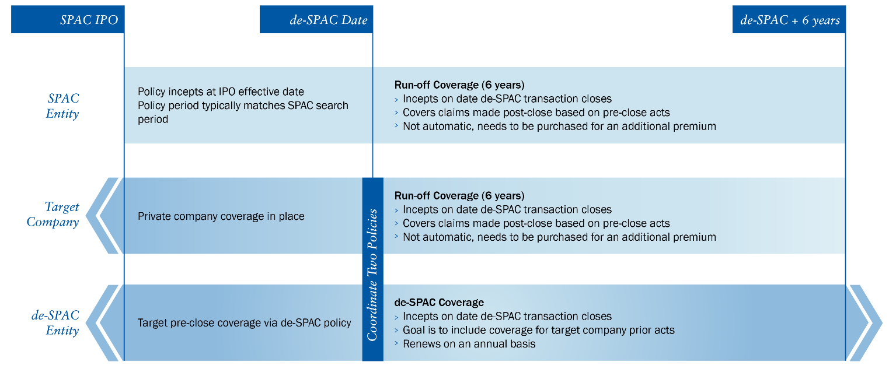Prior Acts Coverage
- Aim to secure coverage for the target company in the go forward policy-goal is to have uninterrupted coverage for public shareholder claims.
- Purchase runoff coverage on private company D&O program for the target company-goal is to maintain coverage for claims that may not be covered by the go forward policy-for example, claims brought by the SPAC against the directors and officers of the target company for misrepresentations in connection with the business combination transaction. The go-forward de-SPAC coverage would likely exclude such a claim due to the Entity versus Insured exclusion.
- Coordinate the policies by aligning the “other insurance” exclusions in each policy.
Add additional Named Insureds to go forward policy
- Specifically add the target company as an Additional Named Insured to the go forward policy-adds certainty of prior acts coverage through the transaction changes.
- Review organizational charts to determine if any other entities should be specifically added.

Obtain “Straddle” language and “Successor in Interest” (SII) language in SPAC runoff policy and “Straddle” language in the go forward policy
- Straddle language helps to ensure claims that name both the go forward company and the SPAC and its insured persons are properly covered and don’t fall into a gap between two policies.
- SII language covers the go forward company for its liability arising from the pre-transaction actions of the SPAC and its insured persons.
General D&O Policy Improvements
- All of the traditional coverage enhancements remain important including application severability, the personal misconduct exclusions, breadth of the definitions of Claim, Loss and Wrongful Act, etc.

VI. Placement Strategy

We typically approach all of the carriers that are active in the public company D&O marketplace in order to provide you with a comprehensive evaluation of your company from an underwriting perspective. There are four key areas that we target during the marketing process; while each is individually important, finding a carrier that can help us to meet all of these objectives on your behalf is our ultimate goal.

- Breadth of Coverage Continually re-evaluate the terms and conditions of the policy forms and coverage enhancement endorsements offered by the various carriers in the marketplace in order to ensure that you benefit from the broadest, most cutting edge coverage available.
- Insurer Quality Confirm that the carriers remain committed to the D&O product line, continue to exhibit a consistent approach to their renewals and have a healthy financial condition and a solid claims-paying reputation.
- Structure of D&O Program / Limit Selection Discuss the structure of your D&O program, measuring the balance between protecting the personal assets of the directors and officers and the balance sheet of the corporate entity. Given the fact that the materially broader terms and conditions will cause these policies to cover more than they ever have in the past, we must also be sure that the limit of liability remains appropriate.
- Competitive Pricing Ensure that we secure the best possible premium while not sacrificing quality of coverage. In addition to using the power of the marketplace to drive the best available premiums, we also draw upon our extensive underwriting experience to pre-underwrite your risk prior to submitting your information to the insurers. This allows us to identify your heightened risks and work with you to proactively develop compelling explanations prior to discussions with the underwriters.

De-SPAC Timeline versus a traditional IPO
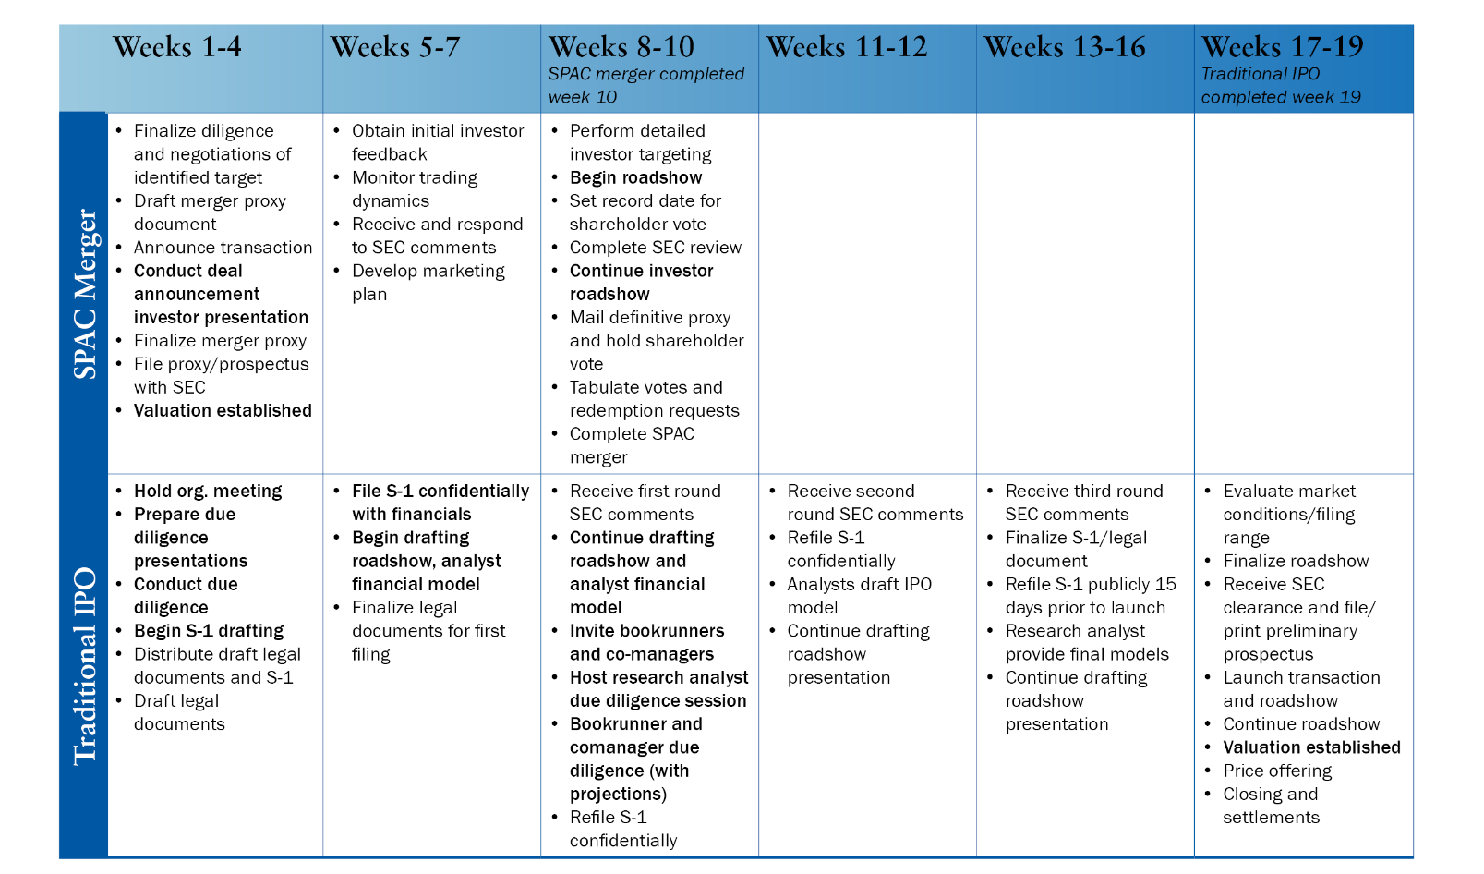
Source: Mayer Brown

De-SPAC Facts

For the 60 de-SPAC transactions closed in 2020, the average filing was 3.5 weeks after deal signing. The shortest was 5 days.

69% of deals were supported by a PIPE offering. The average PIPE in 2020 was $288M and the median was $160M.

2020 SPAC’s saw an average of 97% approval by shareholders.

The listing market for de-SPACs was 72% NASDAQ and 28% NYSE for 2020.

Proposed Placement Timeline
(To be amended and finalized based on discussions with you.)
Date | Action
Deal signed and announced | You provide us with draft deal documents
TBD | We pre-underwrite your risk profile and conduct a call with you to discuss items which will be potential underwriting concerns
TBD | Initial submission to D&O market including our coordinated discussion of potential underwriting issues
TBD | Underwriter meetings/conference calls as needed
TBD | Marketing update  - Consider primary quotations  - Select primary option(s) from which to build excess program  - Evaluate possible excess structures based on quotes negotiated to date
TBD | - Discussion with your counsel regarding primary coverage terms, if desired  - Negotiate excess and Side A quotations
TBD | Final presentation to you and satisfaction of subjectivities (prior to start of road show)  We are available for discussions with your board, if desired
Day before deal close | Insurers prepped and made ready to bind.
Deal closes | Bind orders placed. Inception of D&O program for merged company.

VII. Limits Modeling data
When considering the appropriate limit of liability for a D&O program, we look to two main factors for guidance. First, we look at historical statistics on past settlement values for shareholder class action claims. We then look to the purchasing patterns of companies with similar market capitalizations. Bear in mind that we recommend that our clients speak to their outside securities counsel for their valuable advice.

Industry Perspective While companies in every industry find themselves targets of shareholder class actions, there are clearly sectors that stand out as perennial favorite targets for the plaintiffs’ bar. As usual, in 2021, the consumer non-cyclical industry sector had the most suits-brought, primarily against pharmaceutical, biotechnology and healthcare companies. Claims against financial companies receded to the lowest level in recent memory. And, as in years past, utilities, energy and basic materials companies remained the least sued business classes.

Core Filings by Industry | Average  1997-2020 | 2020 | 2021
Financial | 30 | 29 | 18
Consumer Non-Cyclical | 52 | 66 | 68
Industrial | 17 | 13 | 10
Technology | 23 | 28 | 29
Consumer Cyclical | 20 | 26 | 24
Communications | 27 | 18 | 21
Energy | 7 | 9 | 10
Basic Materials | 5 | 10 | 4
Utilities | 3 | 3 | 0
Total |  | 202 | 184
* Cornerstone Research 2021 Securities Class Action Case Filings Year in Review
A number of different allegations comprise shareholder class action suits:
Core Securities Claim Filings | 2019 | 2020 | 2021
General Characteristics | Percent of Filings | Percent of Filings | Percent of Filings
10b-5 claims | 87% | 85% | 91%
Section 11 claims | 16% | 10% | 14%
Section 12(a) claims | 7% | 11% | 11%
Common Core Filing Allegations
Misrepresentations in Financials | 98% | 90% | 90%
False “forward looking” statements | 47% | 43% | 43%
GAAP violations | 23% | 27% | 22%
Insider Trading | 5% | 4% | 6
Cornerstone Research 2021 Securities Class Action Case Filings Year in Review

Certain areas of the country have been more litigious than others in terms of the number of securities class actions. The following chart breaks down settlements by circuit court. Of particular note, the ninth circuit, which encompasses northern California and the second circuit, which includes New York, continue to garner the majority of the litigation activity.
Core Filings by Court Circuits | Number of Cases
Court Circuit | Average  1997 – 2020 | 2020 | 2021
1 | 8 | 2 | 4
2 | 54 | 76 | 82
3 | 18 | 24 | 14
4 | 6 | 3 | 6
5 | 11 | 9 | 8
6 | 8 | 7 | 6
7 | 8 | 7 | 4
8 | 6 | 1 | 1
9 | 49 | 77 | 57
10 | 6 | 6 | 3
11 | 14 | 8 | 7
12 | 1 | 0 | 0
Total |  | 220 | 192

Cornerstone Research 2021 Securities Class Action Case Filings Year in Review


Historical Securities Litigation Settlement Values
A leading indicator for exposures facing directors and officers is the median values. Irrespective of the source, the chart shown below clearly illustrates an uptick in median settlements. Please note that defense costs are not reflected in the amounts shown below.
To provide some perspective, using NERA’s numbers, in 1996, the median settlement was $3.7 million, while in 2000 it was $4.8 million, and then $6.1 million in 2003. As a result of the financial crisis of 2008 to 2009, median settlement values rose to $11 million in 2010 and hit a record of $12.6 million in 2012. Through the ensuring recovery years, the median settlement value drifted back down between $7 million and $9 million and then returned to the $12 million to $13 million level since 2018.

Shareholder Class Action Settlement Values
Source: | 2019 |  | 2020 |  | 2021
 | Avg. | Median | Avg. | Median | Avg. | Median
Cornerstone | $27.4M | $11.5M | $54.5M | $10.1M | N/R | N/R
NERA* | $28M | $12M | $30M | $13M | $21M | $8M

*Excludes settlements over $1 billion

Current Market Capitalization and Share Price Performance

STOCK CHART

Market Capitalization Information as of 6/23/22
current share price | $34.64 per share
52 week high share price | $34.89 per share
total shares outstanding | 40.48 million
current market cap | $1.40 billion
52 week high market cap | $1.41 billion

Settlements as a Percentage of a Drop in Market Capitalization
All settlements for cases filed and settled post reform with a market capitalization drop during the class period between $500 million and $1 billion (288 data points).
Estimated Settlements
 | Settlement as a percentage of  market cap drop | Estimated Settlement based upon a market cap drop of $600M (50%) from your initial Market Cap
Average Settlement | 1.8% | $10.8M
Median Settlement | 1.1% | $6.6M
1st Quartile Settlement | 0.6% | $3.6M
3rd Quartile Settlement | 2.0% | $12.0M
90th Percentile Settlement | 3.6% | $21.6M
Settlement Range: Minimum $700,000 Maximum: $220 million
Source: Proprietary 2021 Analysis Project performed for RT ProExec by Cornerstone Research

Shareholder Class Action Settlements
(By market capitalization at start of class period)
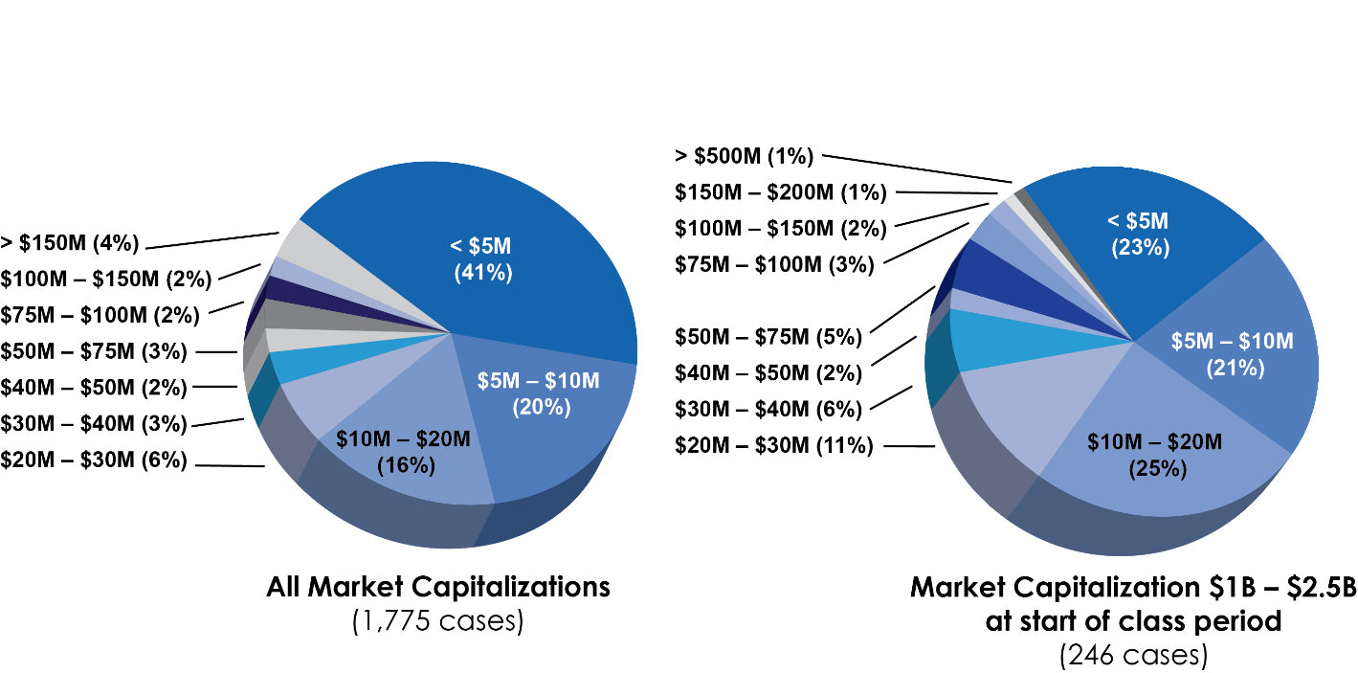
Source: Proprietary 2021 Analysis Project performed for RT ProExec by Cornerstone Research

Median Shareholder Class Action Settlements

(As a Percentage of NERA Defined Investor Losses* by Level of Investor Losses, December 2012-December 2021)

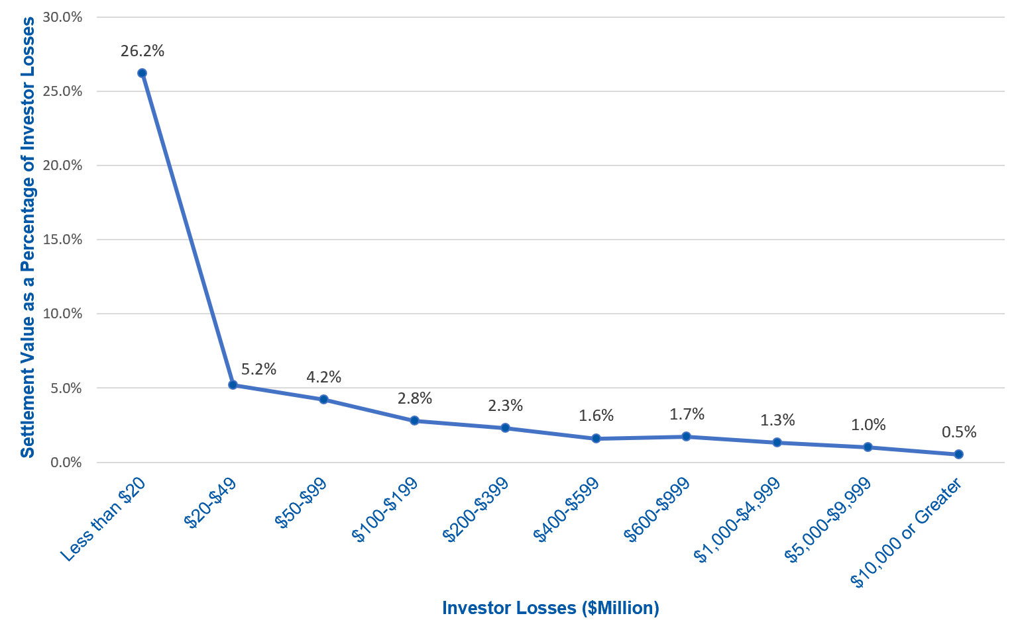
Source: Nera Economic Consulting

*NERA Defined Investor Losses is a measure of the aggregate amount that investors lost from buying a defendant’s stock rather than investing in the broader market during the alleged class period. Note that smaller cases settle for higher percentages of investor losses, and, while aggregate settlement values certaily increase as cases get larger, larger cases settle for significanltly lower percentages of shareholder losses.
While this data is helpful, it cannot be viewed in a vacuum as it is impossible to predict how the broader stock market will perform in a future period that coincides with a potential shareholder class action class period.

Regarding Notes and Preferred Stock

The above data projects possible loss scenarios based on losses to your common shareholders. Generally speaking, absent a bankruptcy or other financially catastrophic situation, preferred shareholders and bondholders tend to be much less litigious than common shareholders. However, in the event that preferred shareholders or bondholders do bring suit, their litigation can significantly impact a D&O program. Unfortunately, there are no data sources analogous to Cornerstone Research that would allow us to quantify the potential impact of suits by these securityholders, but it is important to take this issue into consideration, at least qualitatively, when deciding on the appropriate limit.

A note on defense costs
It is imperative to note that the settlement value figures discussed above do not include the impact of defense costs, which are also paid from the D&O policy limits. Historically, shareholder litigation experts warned that companies sued in shareholder class actions can expect to pay an amount equal to one third of the settlement value in defense costs. As the rates charged by defense firms continue to increase and the complexity and costs of supplying information during discovery continues to skyrocket, we expect that defense costs will continue to increase as well.
Defense costs also increase exponentially when other actions are brought alongside a shareholder class action. These other actions may include opt-out suits and derivative suits as well as investigations and suits by the SEC and/or DOJ which may result in multiple defense counsel being retained to represent the potentially divergent interests of the various Insureds under the policy.

Historical SPAC Claim Settlements
There have been relatively few settlements of SPAC related shareholder litigation. This is due in large part to the relatively limited number of SPAC offerings that had been consummated prior to 2019. The following provides detail on the five SPAC litigation settlements that we are aware of.
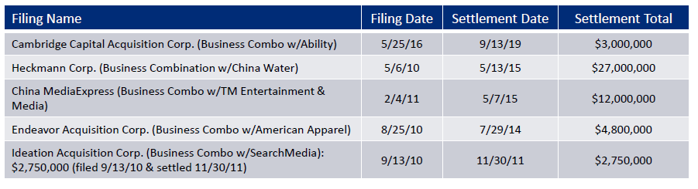

Cambridge Capital Acquisition Corp./Ability Inc.: Cambridge Capital Acquisition Corp. was a publicly traded blank check company that in 2015 merged with Ability Computer & Software Industries, an Israeli surveillance, decryption, and cybersecurity firm. The merger resulted in the formation of Ability, Inc., which continued as a public company.
In May 2016, plaintiff shareholders filed a securities class action lawsuit against Ability in the Southern District of New York. The defendants named in the lawsuit included not only Ability and certain of its directors and officers, but also the former CEO of Cambridge Capital Acquisition. The plaintiffs alleged that in the proxy statement in which Cambridge sought shareholder approval of the merger, as well as various other statements both before and after the merger, the defendants mispresented Ability’s financial condition.
After the merger was approved, Ability had to restate its financial statements for several reporting periods prior to the merger. After the plaintiffs filed an amended securities complaint, the parties to the securities litigation negotiated a settlement.

Heckmann Corporation/China Water: Heckmann Corporation was a special purpose acquisition company organized in 2007. Its principals included former Vice President Dan Quayle and former Notre Dame football coach Lou Holtz. Heckman completed an IPO in December 2007.
In May 2008, Heckmann announced that it had entered an agreement to merge with China Water, a Nevada corporation engaged in the manufacture and distribution of bottled water in China. The merger was completed in October 2008.
In the subsequent securities class action, the plaintiff shareholders allege that both in the proxy statement issued in support of the proposed merger as well as other public statements prior to the merger, and in public statements subsequent to the merger, the defendants misrepresented China Water’s financial performance and condition.
The lawsuit, which was filed in the District of Delaware, the plaintiffs alleged that financial results presented in the proxy statement were “a complete sham.” The defendants in the lawsuit included several directors and officers of the SPAC (including, among others, Quayle and Holtz), as well as China Water and several China Water executives. The case ultimately settled in 2015.

China MediaExpress/TM Entertainment & Media: TM Entertainment & Media was a blank check company that completed an IPO in October 2007. In January 2009, TM entered an agreement to acquire Hong Kong Mondefu Holding Ltd., a privately held television advertising company based in the People’s Republic of China. The combined companies emerged as a publicly traded entity renamed as China MediaExpress.
In the subsequent securities class action lawsuit, the plaintiffs alleged that in the proxy statement issued in support of the merger and in post-merger statements, the defendants made material misrepresentations about China MediaExpress’s operations, financial performance, and financial condition.
The defendants included China MediaExpress and several of its executives, who had previously served as directors and officers of Hong Kong Mondefu. The individual defendants also included two former officers of TM Entertainment & Media. The case ultimately settled in May 2015.

Endeavor Acquisition Corp./American Apparel: Endeavor Acquisition Corp. was formed in July 2005 as a blank check company. Endeavor completed its IPO in December 2005. In November 2006, Endeavor entered an agreement to merge with American Apparel. The merger was completed in December 2007, with American Apparel as the surviving entity and as a publicly traded company.
In the months following the merger, American Apparel experienced an increasingly serious number of immigration related issues having to do with the immigration status of workers in its manufacturing facilities. These issues led to immigration enforcement actions and adverse publicity, and caused American Apparel’s share price to decline. American Apparel shareholder filed a securities lawsuit against the company, its founder and CEO, its CFO. The shareholders alleged that investors had been misled about the company’s business practices. The lawsuit settled in July 2014.

Ideation Acquisition Corp./Search Media: Ideation Acquisition Corp. was a blank check company that completed an IPO in November 2007. In April 2009, Ideation announced its plan to merge with SearchMedia International Ltd., an outdoor advertising firm operating in China and organized under the laws of the Cayman Islands. The merger was completed in October 2009, with SearchMedia Holdings Ltd. as the successor entity, and as a publicly traded company.
In the months following the merger, SearchMedia announced that its prior financial statements, including statements for the period prior to the merger would have to be restated. When the restated financials ultimately were published, the company disclosed among other things that “financial irregularities” had been uncovered, which had resulted in the significant overstatement of revenues. The company’s share price declined, and plaintiff shareholders initiated a securities class action lawsuit. The named defendants included SearchMedia and eight former directors and officers of Ideation. The case settled in November 2011.

Peer Purchasing Data
Once we have analyzed the historical statistics on past settlement values for shareholder class action claims, we then look to the purchasing patterns for companies with similar market capitalizations. When evaluating peer data, it is also important to consider other factors that reflect each Company’s unique risk profile and might suggest more or less limits as being appropriate than for the average company in the same market cap range. Items to consider when sizing a D&O program include:
- Revenue model | - Planned / recent insider sales
- Strength of balance sheet | - Claims activity
- M&A activity | - Board / corporate philosophy
- Industry dynamics  - Public Offerings | - Board net worth  - Regulatory Environment

RT ProExec Peer Limits Data: Total Limits by Market Capitalization
Industry: All Market Capitalization $1B to $2.5b Time Period: Previous 12 Months
Public D&O Peer Group Limit Purchasing Data Analysis
 | Total Limit | Side A Limit
Average Limit | $53,000,000 | $14,400,000
Median Limit | $50,000,000 | $10,000,000
3rd Quartile Limit | $60,000,000 | $20,000,000
90th Percentile Limit | $65,000,000 | $26,500,000
Market Cap Range: Minimum $1 billion Maximum: $2.5 billion
Source: Proprietary 2021 Analysis of RT ProExec Public Company D&O placements

* Cornerstone Research 2021 Securities Class Action Case Filings Year in Review

VIII. Marketplace Update
Notwithstanding the fact that there are a number of insurers that will provide quotations for your placement, the selection of your D&O insurers should be made only after careful consideration of a number of factors.
Financial Rating It can be difficult to accurately analyze an insurer’s financial strength because claims can take three or more years to resolve. Thus it is important when evaluating financial strength to consider not just the rating today, but what the rating might be at the time a claim will be paid. The impact of the subprime crisis on insurers has become a key focus for the rating agencies and we will keep you apprised as further information becomes available.
Track Record An insurer that has proven its commitment to the D&O market should not be undervalued. Some insurers have come and gone opportunistically and/or greatly shifted their use of reinsurance, while others have demonstrated an ongoing commitment to their insureds and to the market.
Claims Expertise D&O coverage issues are complex. It is important to select an insurer, particularly on a primary basis, that has the institutional knowledge and expertise to understand and efficiently resolve these issues. Securities defense counsel is typically a good reference on this topic.
Above all else, the most important consideration when purchasing a D&O program is the quality of the coverage provided by the policy form. There are more than 40 insurers that currently provide D&O coverage for publicly traded companies and no two insurers’ policies are exactly alike, meaning that there are multiple policy forms with provisions that can vary widely. This, coupled with the fact that we continue to face an ever-changing legal landscape, makes it our duty as your broker to keep up with the latest decisions and how they can affect the exposures facing directors and officers.

D&O Market Overview
Superior A++ | Chubb  Berkshire Hathaway  Tokio Maine HCC  Travelers
Superior A+ | Allianz  Arch Capital Group  ATRI Insurance Services (Fair Co)  AXA XL  Berkley  Everest  Forge Underwriting (Partner Re)  Great American  Hartford (including Navigators)  Intact Financial (formerly OneBeacon)  Munich Re  Nationwide  Old Republic (Chicago Underwriting Group)  RLI  RSUI Indemnity  Sompo  Swiss Re  Zurich
Excellent A | AIG  Ambridge  Applied Underwriters  Aspen Specialty  AWAC (Allied World Assurance Co.)  Ascot  AXIS  Bowhead Underwriting (American Family)  Canopius  Capitol Specialty  CNA  Crum and Forster  DUAL  Hudson  Ironshore  Lloyd's of London (Beazley, Hiscox, StartPoint, Inigo, Convex, SCOR, IQUW, Ki, Tegron)  Markel  QBE  Starr Indemnity  Westfield
Excellent A- | AmTrust Financial (ANV and Euclid)  Arcadian (Third Point Re)  Argo Group  Coaction Global (ProSight)  Core Specialty (including Celerity Pro)  Guide One  Hallmark  Orion  Skyward Specialty  Vantage
Source: AM Best The above rating information is provided for informational purposes only and is not comprehensive. For complete and current information on AM Best ratings, please visit their website at www.ambest.com.
Appendix A. Securities Litigation Loss Prevention
There are a variety of steps that IPO companies can take as part of the day-to-day operations in order to reduce their risk of securities litigation. Because of the heightened securities litigation risk that they face, it is particularly important that IPO companies consider discussing with their outside counsel the adoption of prudent securities litigation loss prevention measures.

Insider Trading The typical securities fraud lawsuit is triggered by a company's announcement of bad news followed by a significant drop in the company's stock price. Plaintiffs likely will allege that the defendants fraudulently misrepresented or concealed material information in an effort to inflate the company’s stock price. Evidence of any insider sales prior to the release of the bad news will significantly magnify the defendants' liability exposure, because plaintiffs will attempt to use insider sales as evidence of the defendants’ fraudulent intent.

Plaintiffs' ability to use insider trading this way may arise not so much from the defendants' actual fraud as from the appearance of fraud, i.e., the suggestion that insiders misrepresented or concealed information in order to profit or avoid losses in their own company stock portfolio. Defendants may ultimately defeat the allegations, but the appearance of fraud tied to insider trading could preclude early dismissal of the lawsuit, resulting in protracted and costly litigation for both the company and its directors and officers.

The single most important step for a company to take to reduce its securities litigation exposure is to institute procedures to eliminate insiders trading their shares of the company’s stock in suspicious amounts at suspicious times. Well-advised companies will review with their outside counsel the possibility of instituting written insider trading guidelines that identify procedures governing all trades in company securities by directors, officers and employees. The implementation of well-crafted written guidelines can reduce the possibility of trading at times that might be viewed as suspicious in a litigation context. The written insider trading guidelines should encompass at least the following: the identification of a central trading compliance officer; the establishment of trading windows and blackouts; and a procedure for the institution of special blackouts during particularly sensitive times.

Another way to try to eliminate the possible adverse inference that might otherwise arise from insider trading is for insiders who anticipate trading their shares to adopt written trading plans. The SEC's Rule 10b5-1 specifies the steps that individuals can take to reduce insider trading risks. Trades made pursuant to a Rule 10b5-1 trading plan cannot be used as the basis from which to try to draw the inference of fraudulent intent. Rule 10b5-1's provisions are designed to provide "appropriate flexibility to persons who wish to structure securities trading plans and strategies when they are not aware of material nonpublic information, and do not exercise any influence over the transaction." These provisions specify several means by which persons may safely trade in their own holdings of the company's securities; individuals may:
- Enter into a binding contract to purchase or sell the security;
- Provide instructions to another person to execute the trade for the instructing person's account; or,
- Adopt a written plan for trading securities.
The company’s outside counsel can provide detailed advice on structuring Rule 10b5-1 trading plans.

Disclosure Practices A company and its management can protect themselves from securities litigation risks by using the company’s periodic SEC reports and other regular shareholder reports as an opportunity for "defensive disclosure" of known trends, uncertainties and business risks that the company faces. In order to achieve the purposes of defensive disclosure, the company's periodic reporting must focus on events both internal and external to the company that would cause the reported financial information to be not necessarily indicative of its future operating results or financial condition. The same considerations that apply to the disclosure of "risk factors" in a company's Registration Statement at the time of its IPO could be applied to the company's disclosure in its periodic reporting.

The potential benefit for companies adopting disciplined disclosure practices was significantly enhanced when Congress included “safe harbor” protection in the Private Securities Litigation Reform Act. The safe harbor provisions provide immunity from securities liability for forward looking statements if certain disclosures accompany the statements. The Act's safe harbor protection will be most valuable for companies that habitually discipline their communications procedures to bring their statements within the disclosure requirements.

In order to avail itself of the protection of defensive disclosure and to take advantage of safe harbor provisions, well-advised companies may wish to consider discussing with their outside counsel the adoption of an internal written policy statement dictating procedures to ensure disclosure. Any policy should include at least the following elements:
- A commitment to provide stockholders and potential investors with the information they need to understand the company's financial condition and the material known risks, trends and uncertainties that the company faces.
- An undertaking to include in periodic reports a separate section where the company discusses known risks, trends and uncertainties, and also to ensure that any optimistic statements in the company's periodic reports are accompanied by precautionary disclosure of any barriers that might prevent the optimistic expectations from being realized.
- The establishment of a checklist to ensure that all communications contain the requisite language to bring all forward looking statements within the protection of the safe harbor provision.
- The identification of specific person(s) knowledgeable about the company to review draft periodic reports to ensure disclosure of material known risks, trends and uncertainties.
- The specification of the persons responsible for ensuring that all of the company’s public statements comply with the procedural requirements of the safe harbor provisions.
The procedures that are adopted should not be broader than the company is willing to enforce; a disclosure policy that is not followed could cause greater harm than no policy at all. The company’s outside counsel can help structure disclosure policies that are adapted to the company’s circumstances.

Analyst Communications Numerous dangers arise in a company’s communications with securities analysts. The main pitfall is that analyst projections could be treated as the company's own statements in securities litigation, depending on the company's conduct. This “attribution” of the analyst’s statements to the company can arise if a company official is the source of a misstatement in the analyst’s report. Analyst’s statements may also be attributed to the company if the company undertakes to review and comment upon draft analyst statements and thereby becomes “entangled” with the statements in the analyst reports.

In addition to the risks of attribution and entanglement, further analyst communication pitfalls arise under Regulation FD. The SEC adopted Regulation FD to specify more clearly the procedures a public company must follow to provide equal access to material information, and to make clear the type of selective disclosure that is prohibited. Regulation FD requires public companies to simultaneously release material information on a widespread basis if the information is intentionally provided to securities markets professionals (i.e., analysts, investment bankers) or shareholders when it is reasonably foreseeable that the market professional or shareholder will trade on the basis of the information.
There are a number of steps that companies can take to reduce their Regulation FD exposure and the securities litigation risks arising from their communications with analysts:
- Designate one or two spokespersons who make all public statements and who respond to inquiries from the public, shareholders and analysts. The spokespersons should be kept apprised of all material company developments, and should be aware of all information regarding the company that has been previously disclosed in the marketplace.
- Prepare a script for private analyst communications that has been approved by securities counsel (and/or others charged with final review authority for outside communications) to ensure that the script does not contain any material non-public information, and then follow the script
- Avoid reviewing draft analyst reports, to avoid having the company becoming so entangled with the analyst’s report that the analyst’s statements become attributable to the company.
The company’s outside counsel can help structure disclosure policies that are adapted to the company’s particular circumstances.
This section is provided for informational purposes only and is not intended to provide legal advice. The issues and suggestions presented in this section should be reviewed with outside counsel. Any change in corporate processes or practices should be discussed with outside counsel before implementation.

Appendix B. Notable D&O Related Supreme Court Decisions
Decision/Date | Impact
Lorenzo v. SEC, March 27, 2019 | A person who knowingly dissemination a false statement can be liable under the federal securities laws “scheme liability” provisions, even if the person did not “make” the false statement and therefore cannot be held liable under the federal securities laws’ “misrepresentation” provisions
Cyan, Inc. v. Beaver County Employees Retirement Fund, March 20, 2018 | State courts retain concurrent jurisdiction over class action lawsuits alleging only violations of the Securities Act of 1933 and these lawsuits are not removable to federal court.
Omnicare, Inc. v. Laborers District Council Construction Industry Pension Fund, March 24, 2015 | The Sixth Circuit’s “objective falsity” standard in Section 11 cases is rejected. Allows for challenges to opinions in registration statements if supporting facts are misleading or if there are omitted facts that make the opinion misleading.
Halliburton Co. et al. v. Erica P. John Fund, June 23, 2014 | The landmark Basic v. Levinson decision is upheld. Securities litigation defendants may rebut the fraud-on-the-market presumption of reliance before the class certification stage by showing a lack of price impact.
Amgen Inc. v. Connecticut Retirement Plans and Trust Funds, February 27, 2013 | A securities plaintiff is not required to prove that the allegedly misleading statements are material as a prerequisite to class certification.
Janus Capital Group, Inc. v. First Derivative Traders, June 13, 2011 | Because a mutual fund management company did not “make” the actual statements, it cannot be held liable for the alleged misstatements in the prospectuses of the mutual funds it manages.
Erica P. John Fund, Inc. v. Halliburton Co., June 6, 2011 | Securities class action plaintiffs do not have to establish loss causation in order to obtain class certification.
Morrison v. National Australia Bank, Ltd., June 24, 2010 | U.S. securities laws apply only to “transactions” taking place in the U.S., and so the laws do not apply to an action brought by non-U.S. investors who bought shares in a non-U.S. company on a non-U.S. securities exchange.
Merck & Co. v. Reynolds, April 27, 2010 | In order to trigger the running of the statute of limitations for the filing of a securities lawsuit, the plaintiffs must be on notice of facts that would allow the plaintiffs to plead scienter.
Stoneridge Investment Partners, LLC v. Scientific-Atlanta, Inc., January 21, 2008 | There is no private right of action for “scheme liability” or “aiding and abetting” under Section 10(b) of the Securities and Exchange Act of 1934.
Tellabs, Inc. v. Makor Issues & Rights, Ltd., June 27, 2007 | Imposed stringent standard for pleading “scienter” under the PSLRA. In order to satisfy the pleading standard, plaintiffs must present “cogent” allegation and the inference of “scienter “must be at least as compelling as any opposing inference.
Dura Pharmaceuticals, Inc. v. Broudo, April 26, 2005 | A securities law claimant must plead and prove “loss causation,” and an inflated purchase price does not by itself constitute or proximately cause the relevant economic loss needed to establish "loss causation."

Appendix C. Claims Management & Additional Resources
Claims Management

As your broker, our most important function is to ensure that your policy responds properly in the event of a claim. A D&O claim can be difficult to navigate for those unfamiliar with the process.
You have access to the services of the most experienced claims advocates in the D&O insurance business:
- Our D&O Claims function is led by Kevin LaCroix, who has been providing counsel on D&O insurance matters for over 35 years. Kevin began his distinguished career as a coverage attorney and partner in the Washington, D.C. law firm of Ross, Dixon & Bell, one of the nation’s preeminent coverage firms. Kevin then served as Claims Manager and later as President of Genesis Professional Liability Managers, a directors’ and officers’ liability insurer located in Beachwood, Ohio. Kevin also served as President of the Professional Liability Underwriting Society.
- Marissa Streckfus is our D&O Claims manager. Marissa is also an attorney and brings 10 years of management liability claims experience with Chubb, a leading D&O insurer.

With these unparalleled claims resources, we are uniquely positioned to represent you if you experience a D&O claim. While the D&O claims process sometimes can be frustrating, the involvement of an experienced claims advocate can help to minimize the problems and increase the likelihood of a smooth claims resolution.

InSights Newsletter
RT ProExec publishes a periodical newsletter called InSights on executive liability and D&O insurance issues. Archived issues of the newsletter can be accessed at http://www.rtspecialty.com.


The D&O Diary Weblog

In addition, Kevin LaCroix also maintains The D&O Diary, an Internet weblog devoted to directors’ and officers’ liability topics. The blog’s readership not only includes professionals in the management liability insurance industry, but lawyers, academics, journalists, and governmental agencies (e.g., the SEC, the Department of Justice, the Public Company Accounting Oversight Board). The blog’s readership is geographically diverse with over 500,000 unique visitors since the beginning of 2008 from over 150 countries. The blog may be found at www.dandodiary.com. As a result of the D&O Diary, Kevin has been interviewed regarding management liability topics by the New York Times, the International Herald Tribune, Dow Jones Newswire, Associated Press, Bloomberg News, and numerous insurance industry publications.
